DAA Practical 9 – Prim's Algorithm (MST)
Design and Analysis of Algorithms

Aim
To implement Prim's Algorithm to find the Minimum Spanning Tree (MST) of a connected weighted graph and calculate its total cost.

Prim's Algorithm

1. Algorithm
Algorithm: Prim's Algorithm (Minimum Spanning Tree)

Aim:
To find a Minimum Spanning Tree (MST) of a connected weighted graph.
MST connects all vertices with minimum total edge weight and no cycles.

Input:
- Connected weighted graph
- Starting vertex

Output:
- Edges present in the MST
- Total cost of the MST

Steps:
1. Start
2. Create a visited set and mark the start vertex as visited
3. Set MST as empty and total_cost = 0
4. Repeat steps 5 to 8 until all vertices are visited
5. Find the minimum weight edge that connects
a visited vertex to an unvisited vertex
6. Add that edge to the MST
7. Add its weight to total_cost
8. Mark the new (unvisited) vertex as visited
9. Print all MST edges and total_cost
10. Stop

Idea:
Start from one vertex.
Always pick the cheapest edge that joins the tree to a new vertex.
Do this until every vertex is included.

Example Graph:
Edges:
A-B : 2
A-D : 6
B-C : 3
B-D : 8
B-E : 5
C-E : 7
D-E : 9

Start from A
MST edges:
A - B : 2
B - C : 3
B - E : 5
A - D : 6
Total cost = 16

Time Complexity: O(V^2) (adjacency matrix version)
Space Complexity: O(V)

Where V = number of vertices

2. Program Code (C Language)
File: Code/prims.c
#include <stdio.h>

#define INF 9999
#define N 5 // number of vertices A B C D E

/*
Prim's Algorithm
Find Minimum Spanning Tree (MST)
Vertices: 0=A, 1=B, 2=C, 3=D, 4=E
*/

int main()
{
// weight matrix of the graph
// 0 means no self edge, INF means no connection
int graph[N][N] = {
// A B C D E
{ 0, 2, INF, 6, INF }, // A
{ 2, 0, 3, 8, 5 }, // B
{INF, 3, 0, INF, 7 }, // C
{ 6, 8, INF, 0, 9 }, // D
{INF, 5, 7, 9, 0 } // E
};

char name[] = {'A', 'B', 'C', 'D', 'E'};
int visited[N] = {0, 0, 0, 0, 0};

int edges_needed = N - 1; // MST has V-1 edges
int total_cost = 0;
int count = 0;

int i, j;
int from, to, min_weight;

// start from vertex A
visited[0] = 1;

printf("Edges in Minimum Spanning Tree:\n");

while (count < edges_needed)
{
min_weight = INF;
from = -1;
to = -1;

// find smallest edge from visited to not visited
for (i = 0; i < N; i++)
{
if (visited[i] == 1)
{
for (j = 0; j < N; j++)
{
if (visited[j] == 0 && graph[i][j] < min_weight)
{
min_weight = graph[i][j];
from = i;
to = j;
}
}
}
}

// add this edge to MST
visited[to] = 1;
total_cost = total_cost + min_weight;
count++;

printf("%c - %c : %d\n", name[from], name[to], min_weight);
}

printf("Total cost of MST: %d\n", total_cost);
printf("Time Complexity: O(V^2)\n");
printf("Space Complexity: O(V)\n");

return 0;
}

3. Output
Sample program output:
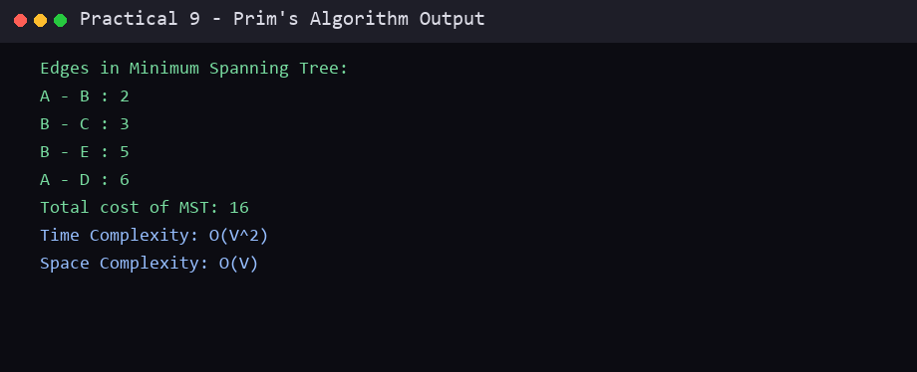

Conclusion
In this practical, Prim's Algorithm was studied and implemented successfully in C. The algorithm finds a Minimum Spanning Tree by repeatedly selecting the cheapest edge that connects a visited vertex to an unvisited vertex. The algorithm, program code and sample output are recorded above.
End of Practical 9

